TECH STACK

**⚙️ Full Tech Stack for QR-Based URL Safety Checker (PWA)**

**🧩 1. Frontend (User Interface)**

|  |  |  |
| --- | --- | --- |
| **Layer** | **Technology / Library** | **Purpose** |
| Markup | **HTML5** | Structure of the UI |
| Styling | **CSS3** (+ optional Tailwind) | Styling the app, light/dark mode support |
| Interactivity | **JavaScript (Vanilla)** | Core logic, QR scanning, UI updates |
| QR Scanner | html5-qrcode | JS library to access camera and scan QR codes [npm install html5-qrcode] |
| Theme Toggle | Custom JS / Local Storage | Toggle and save light/dark theme state |
| PWA Support | manifest.json, service worker | Installable, splash screen, offline shell |
| Animations | CSS transitions / JS / Lottie | Visual feedback for safety results |
| Scan History | localStorage | Store past scanned URLs locally |

**🔗 2. Backend (API & Processing Layer)**

|  |  |  |
| --- | --- | --- |
| **Layer** | **Technology / Library** | **Purpose** |
| Framework | **Flask (Python)** | Handle API routes for checking URL safety |
| HTTP Requests | requests (Python lib) | To call Google Safe Browsing API |
| Threat Parsing | JSON parsing (json module) | Parse response from GSB API |
| Reporting | Custom logic / file storage | Save suspicious reports (optional) |
| CORS | flask-cors | Enable frontend-backend communication |

**🔐 3. External Services**

|  |  |  |
| --- | --- | --- |
| **Service** | **Use** | **Notes** |
| **Google Safe Browsing API** | URL safety verification | Requires API key, free tier available |
| **LottieFiles (optional)** | Animated icons for feedback | Can embed JSON animations in frontend |

**📦 4. PWA Integration**

|  |  |  |
| --- | --- | --- |
| **Component** | **Tool/Config** | **Purpose** |
| Web Manifest | manifest.json | Defines app name, icons, colors, etc. |
| Service Worker | sw.js (basic version) | Enables installability, shell caching |
| App Icons | PNG / SVG | For home screen & splash screen |
| Prompt Logic | Custom JS | Show "Add to Home Screen" logic |

**💾 5. Deployment (Suggested Stack)**

|  |  |  |
| --- | --- | --- |
| **Part** | **Tool / Service** | **Notes** |
| **Frontend** | Netlify / GitHub Pages | Easy deployment, PWA support |
| **Backend** | Render / PythonAnywhere | Host Flask app, handles API calls |

**🛠️ 6. Development Tools**

|  |  |
| --- | --- |
| **Tool** | **Purpose** |
| **VS Code** | Development IDE |
| **Postman** | API testing |
| **Browser DevTools** | Testing PWA behavior & responsiveness |
| **Git + GitHub** | Version control |
| **Icons8 / Canva** | Icons & splash screen design |

**✅ Summary of Key Packages to Install**

# Frontend (if managing with npm)

npm install html5-qrcode

# Backend (Python)

pip install flask flask-cors requests

📁 Project Folder Structure

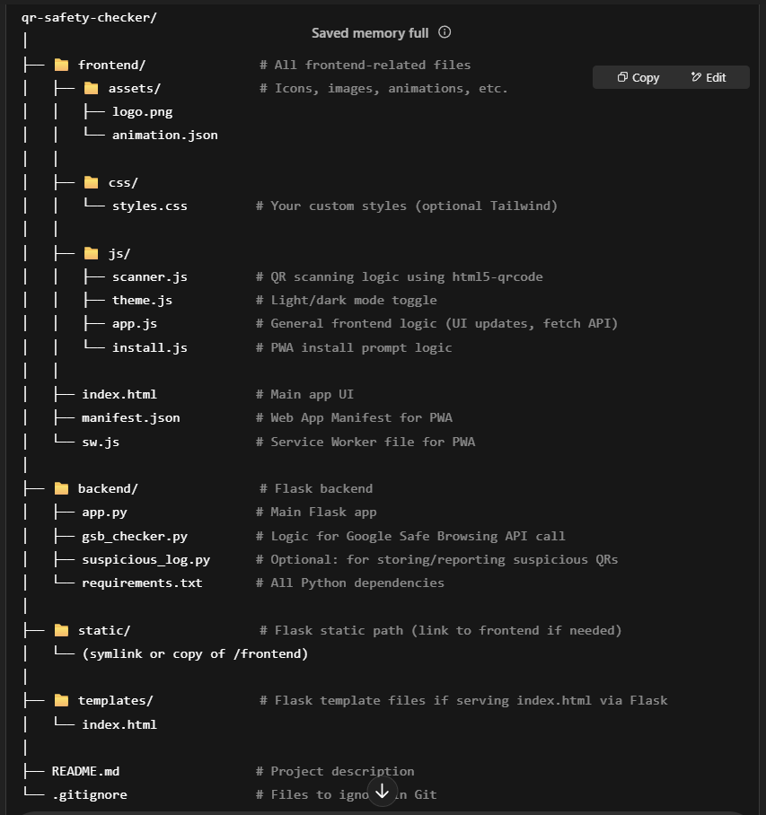

**🔍 How the Structure Works**

* frontend/ contains your **PWA UI**: HTML, JS, CSS, icons, service worker, etc.
* backend/ contains your **Flask API server** which:
  + Receives scanned URLs
  + Checks them via Google Safe Browsing API
  + Returns results
* static/ and templates/ are Flask defaults:
  + If you choose to serve your frontend directly via Flask, move your index.html into templates/ and assets into static/
* You can use README.md to document:
  + Project goals
  + Setup instructions
  + API key usage

END